Kit Old El Paso de General Mills

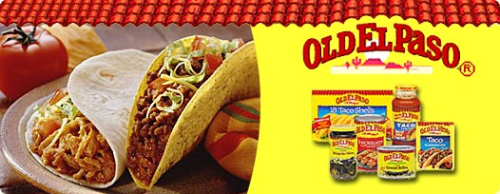

Old El Paso
For nearly a century, Old El Paso has been helping and inspiring consumers to bring fun and flavorful Mexican food to their dinner tables. Trusted to create delicious Mexican meals with mainstream appeal, Old El Paso spices up meal planning.
Popular Old El Paso products include dinner kits, taco shells, seasonings and a complete line of Mexican meal components. Old El Paso brings families and friends together for a fun and lively meal.
